Straw Rockets Activity

Subject: Aerospace Engineering  Related Subjects: | Grade Level(s):  Length of Lesson: | Type: Inquiry / Design / Project  Keywords: Rockets, thrust, drag, lift, gravity

Lesson Overview
A rocket is a vehicle that obtains its thrust from a rocket engine. They are usually lightweight and extremely powerful. Their streamlined body allows them to obtain very high speeds with relatively good efficiency. Rockets have a variety of uses including space travel, satellite launching, missiles, and fireworks. Most Currently, all spacefaring rockets get their power and thrust from chemical thrust—the combustion of certain chemicals can release a large amount of energy. Some rockets can use gun powder for thrust.
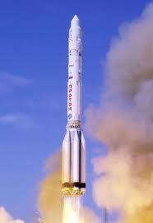

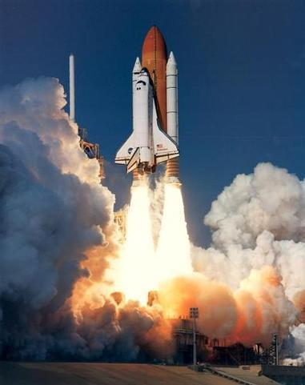

Lesson Focus
Students will create the rocket body from the paper. They can choose how much to use, keeping in mind the effects of added weight. They will design a cone and fins from the index card and add it to their body.

Lesson Objective(s) | - Students will learn what an aerospace engineer does.  - Students will learn the four components of flight.  - Students will build a simple paper rocket.

Lesson Timing

Time | Description
2:30-2:35 | Introduce the Lesson  - Ask Pre-Lesson Questions  - Go Over Vocab
2:35 | Person of Color
2:35-3:00 | Lesson
3:00-3:15 | Lesson Wrap Up & Assessment
3:15-3:30 | Lesson Cleanup

Materials | - Tape  - Sheet of paper  - Straw  - Scissors
Instructor Prep | - Step 1
Related Resources | - List related lessons/ppts etc available from USC or outside, trusted orgs

Lesson Plan

Introduction
- Do you know what an Aerospace engineer does?
  - Yes, designs and builds aircraft and spacecraft.
- What are the four components of flight?
  - Thrust
  - Drag
  - Gravity
  - Lift
- What do the fins of a rocket do?
  - Provide stability and makes rocket travel in straight line

Procedure
- Cut a 1.5 inch strip off the paper.
- Wrap the piece of paper around the straw and tape it to form the body of the rocket.
- Cut a semi-circle out of the paper and roll it to make a cone shape.
- Tape the cone shape to one end of the rocket.
- Cut out 3 fins for the rocket in triangle shapes.
- Tape the fins to the other end of the rocket.

Wrap-up
The purpose of the survey is to let us know your opinions about today’s project. Remember there are no right or wrong answers.

 |  | Strongly Disagree | Disagree | Undecided | Agree | Strongly Agree
1 | The project increased my interest in science
2 | After this project, I am more confident in doing science

3. What does an aerospace engineer do?

4. What are the four components of flight?

5. What do the fins of a rocket do?

Lesson Background for Teachers

Suggested Real-World STEM Connections
- List possible related Role Models in STEM (with details and links to more reading). Give suggestions for examples of scientists/engineers who are from underrepresented groups in STEM in related careers.
- List related real-world engineering problems and examples

Lesson Variations and Options
Include descriptions of alternative methods or ways to present things.

Explanation
Students today will be making a rocket using wind power. The thrust will come from the human lungs! By blowing into the straw, the rocket is propelled and its streamlined shape will allow it to fly very far.
The body of the rocket is very important. The fins provide stability and allow it to travel in a straight line. The long body and cone reduce air drag. Of course, the weight of the rocket is very important. A heavy rocket takes more power to fly!

Key Concepts and Vocabulary
- Word 1: Grade Appropriate Definition
- Word 2: Grade Appropriate Definition

Safety Notes
- Safety instruction

Person of Color

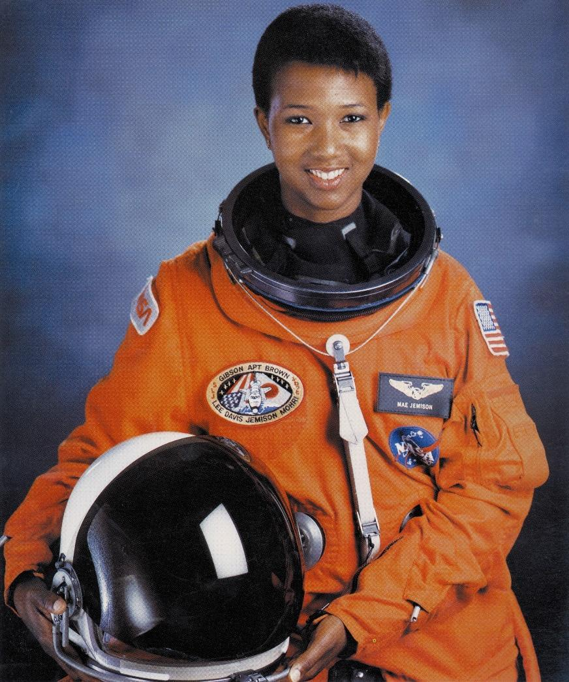

Name: Mae Jemison
Years: XXXX-XXXX
Quick Facts

- First black woman to travel to space aboard the Endeavour in 1992.
- She is also a physician and author of several books on space exploration and detailing her experience while in orbit

